**Database Programming (4203_2)**

**Name: Sakshi Jain Student ID: C0753352**

**Exercise-1**

A college database contains information about professors (identified by professor id) and courses (identified by course id). Professors teach courses, draw an ER diagram that describes the following:

1. Professors can teach the same course in several semesters, and each offering must be recorded.

2. Every professor must teach some course.

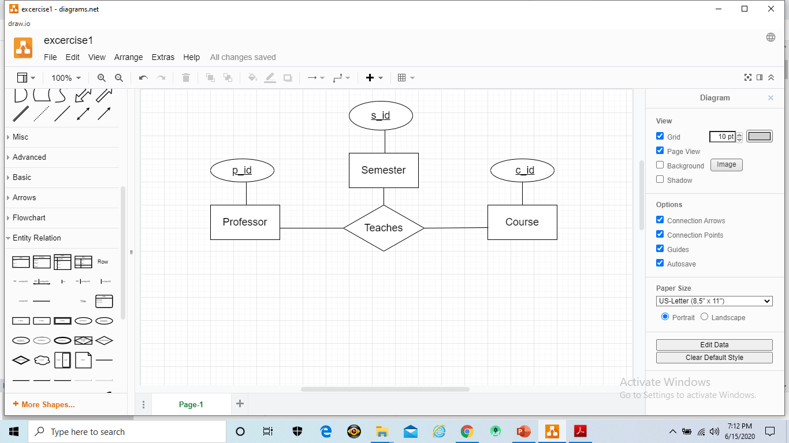

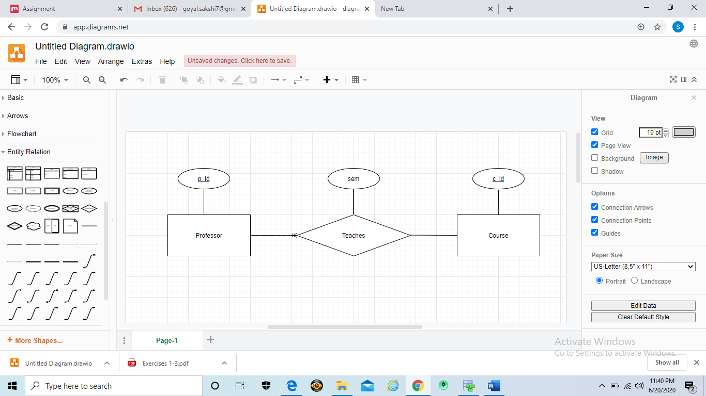

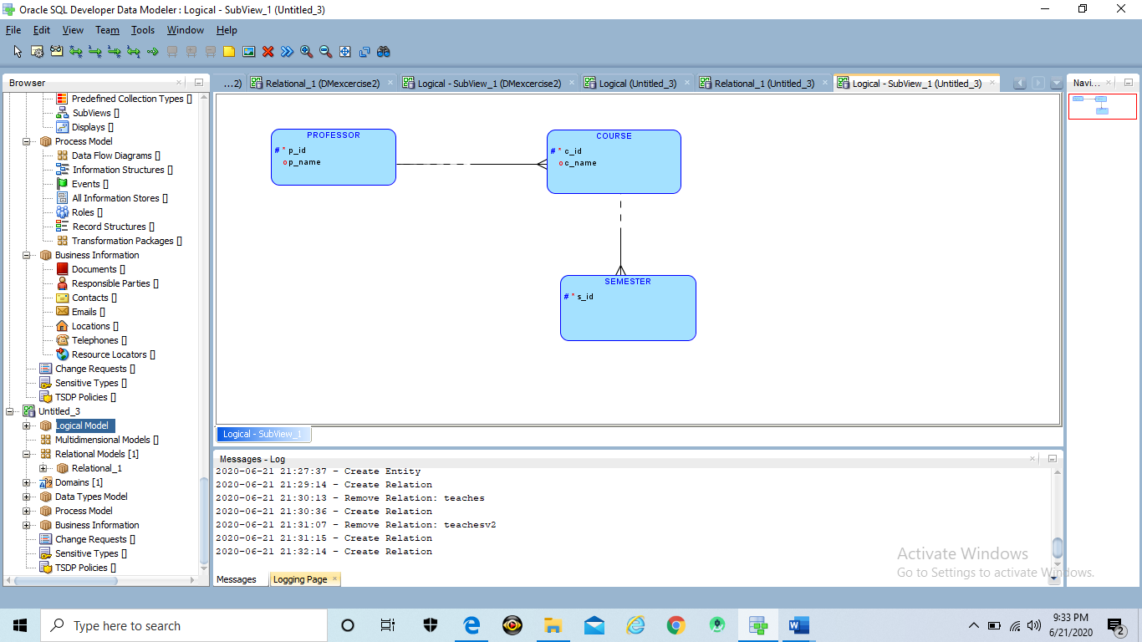

**Exercise-2**

A company has several departments. Each department has a supervisor and at least one employee. Employees must be assigned to at least one, but possibly more departments. At least one employee is assigned to a project, but an employee may be on vacation and not assigned to any projects. The important data fields are the names of the departments, projects, supervisors, and employees, as well as the supervisor and employee number and a unique project number. Use Oracle SQL Modeler to draw ER Diagram and provide a screenshot of your ERD.

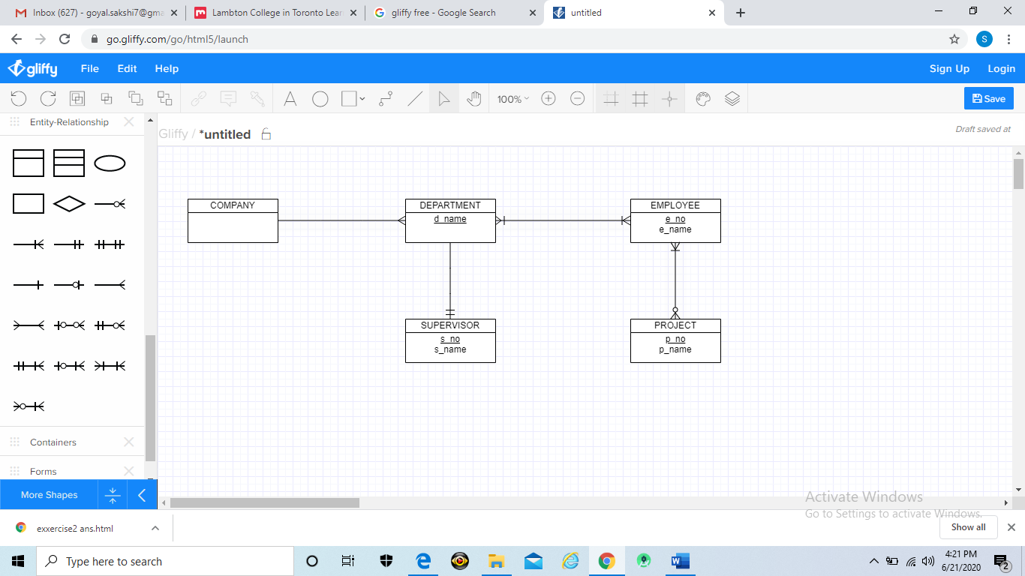

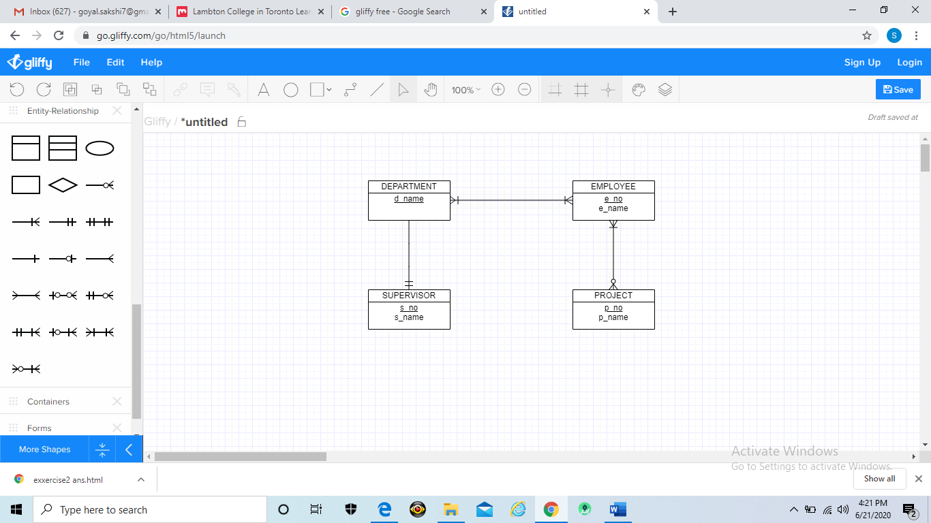

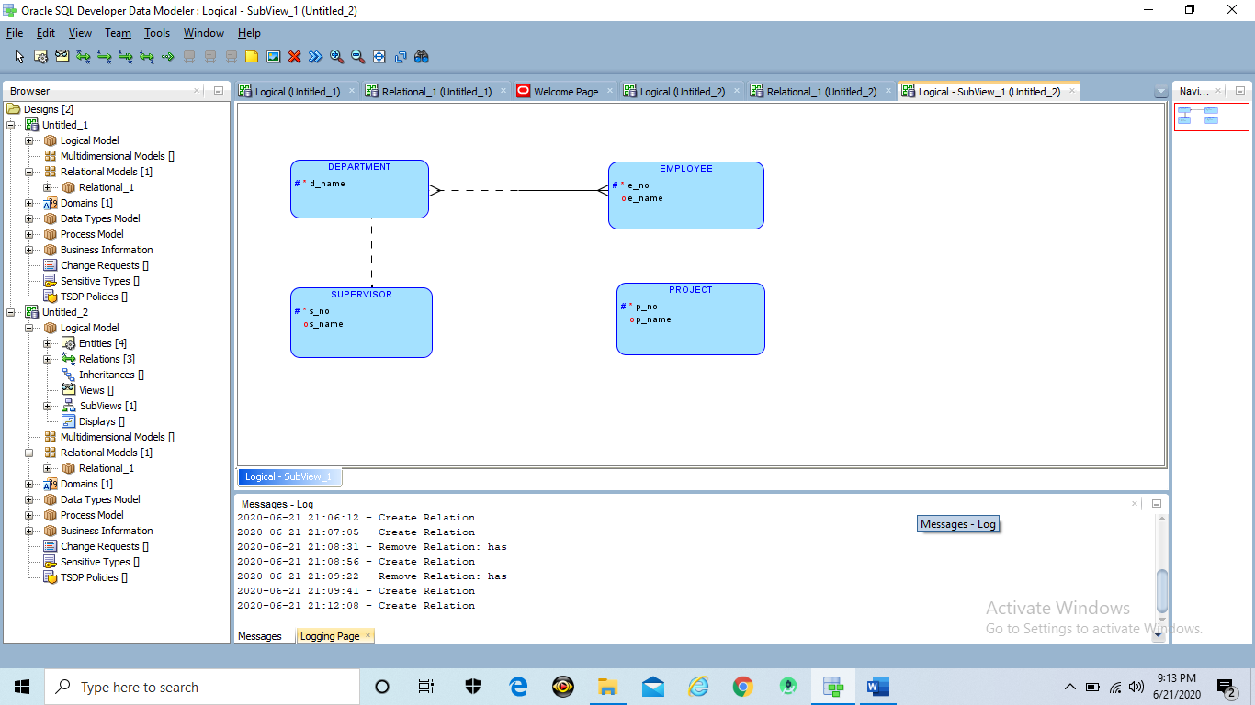

*Note: There is no option that describes Employee-Project relation as shown in above diagram.

**Exercise-3**

Convert the following ER diagram into relational model

